

Predictive Analysis of Medical Insurance Payment Durations in South Africa: A case of LA Health

by

Yolisa Velebayi
3339298

A project is submitted in partial fulfilment of the requirements for the Postgraduate Diploma in Computer Software and Media Applications (with specialisation in Data Analytics and Business Intelligence / e-Logistics)
University of the Western Cape
2025
Supervisor/s: Dr Breytenbach

Abstract
The main objective of the study was to design a model able to predict waiting periods for claim payments and to find out what causes such delays by looking at a large dataset of real claims. Using the CRISP-DM framework, the study examined claims data (a total of 18,967 paid invoices) from LA Health and applied predictive methods such as linear regression, decision tree, gradient boosting, lasso and random forest regressors. The analysis reveals that most payments are made within 2 weeks, with a longer tail at the right (mean = 11.4 days, median = 9 days). Both PMB claims and claims for care from non-contracted suppliers were paid more slowly than other claims (mean 11.73 days for PMBs and 15.22 days for non-contracted, compared to 10.61 days for non-PMBs and 10.82 days for contracted providers). The Random Forest Regressor was most successful, accounting for about 19% of the differences in payment duration. Analysis of feature importance pointed out that Total Cashflow, Total Turnover, patient age, contract status and PMB status predicted the outcome most strongly. Predicted payment durations were then generated for the full dataset and compared against actual values, uncovering consistent underestimation in complex or high-risk cases. A comprehensive dashboard was created to highlight performance trends, gaps, and actionable insights. The results give useful ideas, like extending working relationships with healthcare providers and automating select claims to boost the efficacy of claims handling. In addition, the results show how readiness for NHI in the private sector will be boosted by these changes to healthcare financing in South Africa.

Keywords
Medical insurance, Payment duration, Predicted Payment Duration, Predictive analytics, Modelling, Claims processing, South Africa, National Health Insurance, Machine learning

Table of Contents
Abstract 2
List of Figures and Tables 5
Acknowledgements 6
Glossary 7
1. Introduction and Contextualisation 8
1.1 Background: Private Medical Insurance in South Africa 8
1.2 National Health Insurance (NHI) and the Role of Private Insurance 8
1.3 Literature Review 9
1.4 Business context, Objectives, and Success criteria 10
1.5 Overview of the Current Situation 11
2. Problem Statement 12
2.1 Research Problem 12
2.2 Research Questions 12
2.3 Importance and implications of the problem 12
3. Methodology 13
3.1 Alignment with CRISP-DM 13
3.1.1 Business Understanding 13
3.1.2 Data Understanding 13
3.1.3 Data Preparation 15
3.1.4 Modelling 16
3.1.5 Evaluation 17
3.1.6 Prediction and Comparison of Payment Duration 17
3.2 Ethical Considerations and Data Sources 18
3.3 Risk Identification and Mitigation 19
4. Results 19
4.1 Descriptive Statistics and Exploratory Analysis 19
4.2 Modelling Process 21
4.2.1 Model Performance 21
4.2.2 Feature Importance 23
4.3. Payment Duration Analysis Dashboard 24
5. Interpretation and Recommendations 29
5.1 Interpretation of Results Relative to Business Success Criteria 29
5.2 Practical Recommendations and Business Implications 30
5.3 Limitations and Future Research Directions 31
5.4 Relation to Existing Literature and Studies 31
6. Conclusion 32
7. References 33

List of Figures and Tables

Table 3.1.2: Data Labelling

Table 4.1.1: Descriptive Statistics of Key Variables

Table 4.1.2: Average Payment Duration by PMB Status

Table 4.1.3: Average Payment Duration by Contract Status

Table 4.2.1: Model Performance Comparison

Figure 4.1.1: Distribution of Payment Duration

Figure 4.2.1: Top 10 Features Influencing Payment Duration

Acknowledgements

I am very grateful to Dr Breytenbach for guiding me all the way through this research. I am thankful to my classmates for strongly supporting me and working together on this project.

Glossary

NHI: National Health Insurance
CRISP-DM: Cross-Industry Standard Process for Data Mining
PMB: Prescribed Minimum Benefit
MAE: Mean Absolute Error
MSE: Mean Squared Error
R-squared: Coefficient of Determination
Power BI: Business Intelligence Tool by Microsoft

Introduction and Contextualisation

1.1 Background: Private Medical Insurance in South Africa

In South Africa, private medical insurance supports the health of a number of people and covers a substantial portion of services. According to The Presidency, in 2023, 15–16% of South Africans have private medical aid, whereas 84% depend on the public healthcare system. The way insurance is set up in the US has created major gaps between those who use private plans and those who are uninsured. Many people earning middle to high incomes rely on their private medical plans each year to pay their healthcare bills. Even so, the situation has divided how health is financed which undermines the health results for the entire nation due to unequal access to resources. For example, the state helps private medical care by returning tax payments for medical aid and by educating medical professionals (The Presidency, 2024). Because subsidies are very large, amounting to billions of rands, they mostly help a private system that only serves a few, raising concerns about equal and efficient national health spending. In other words, since private medical insurance is central to healthcare funding in South Africa, it is also known for being both expensive and for who can access it which raises questions on how it will change in the future.

1.2 National Health Insurance (NHI) and the Role of Private Insurance

As a result of existing health differences, South Africa is intending to introduce the National Health Insurance (NHI) which offers essential healthcare to people without creating a financial burden. Since the end of apartheid, the NHI is the biggest change to the healthcare system, meant to unite how the nation’s healthcare is financed and cover the entire population (Chothia, 2023). As the NHI Act (2024) shows, once rolled out, a main NHI Fund will help pay for healthcare, stopping private insurers from offering coverage for any service that the NHI Fund is responsible for (Chothia, 2024). This means private insurance might no longer be the main source of insurance and, instead, could only offer extra plans. Naturally, there has been some confusion and resistance from players in the private health sector.

Both private insurers and hospital groups are concerned about the NHI’s future financial status and celebrate it being as a global example of dealing with overlapping private insurance. Those pushing for NHI agree that it is needed to spend resources on public healthcare and reduce the cost burden on households. At the moment, private healthcare costs are rising too quickly and are no longer affordable to most South Africans (The Presidency, 2024). For now, private medical insurance is important; how well it processes claims and payments may affect the success of health services both today and during the launch of the NHI. Therefore, it is important for us all to know the private sector’s claims payment schedules and any bottlenecks, as this helps us identify where changes in efficiency or equality are key for NHI.

1.3 Literature Review

Both internationally and in South Africa, many researchers have studied how efficiently health insurance claims are processed and payments are made.

Delayed Payments and Problems with Effective Administration
Smith and Mokoena (2021) noticed that missing documents and manual handling are some of the most important reasons for delayed payments in South African medical schemes. Experts pointed out that digital change and automation of processes would cut down the length of the process.

Impact of Provider Contracting and Financial Variables
Lee et al. (2022) showed that payment timelines tend to be affected greatly by the contract status of the provider and the size of what is still outstanding. Machine learning showed that having clear agreements allowed contracted providers to get payments more quickly because processes were improved.

Factors under Policy and Regulation
In 2019, the Health Market Inquiry of the Competition Commission revealed that the private health industry is highly regulated but there is not enough standardization in processing claims. The report called for more openness and standardization of how payments are made.

What Patients and Members Experience
According to Heywood’s research (2022), delays in getting paid by medical schemes may decrease patient trust and lead to financial stress for providers and those being treated by them. The researchers argued that claims management should focus more on what patients need.

Transition to Universal Health Coverage
Molefe, Dlamini and Jacobs (2023) studied the expected outcomes of the NHI transition on private medical insurance. They said that issues with current payment systems should guide how NHI claims and payments are designed, with an emphasis on using data and strong analysis.

All these studies point out the important role administrative, financial, contractual and regulatory factors play in deciding how efficiently payments are made. They further show how predictive analytics can spot problems and guide both management and administrative actions.

1.4 Business context, Objectives, and Success criteria

For this research, the focus is on a private health network in South Africa that manages and pays medical invoices using insurance (medical aid) schemes. On-time payments of claims matter to medical providers, patients and the insurance company, as providers must cover needs, patients looking to avoid financial troubles and the insurer hoping to improve its processes and client happiness by resolving claims as quickly as possible. Since the NHI is under serious consideration, insurance companies now need to prove their effectiveness – the way they deal with claims will become an especially important performance standard as they probably end up working alongside the new national system.

The top business goal is to learn what keeps some claims from being settled faster and to use this knowledge to boost the efficiency of the process. The primary purposes of this research project are to achieve certain business objectives.
- To determine what influences how fast private medical insurance claims are paid
- To develop a model that can anticipate how soon a new claim will be paid
- To give stakeholders actionable information to enhance how claims are processed
- To help explain how private health insurance is likely to develop during South Africa’s shift to the NHI

The project will be considered successful if the analysis and model offer strong results and the organization’s recommendations are relevant to its goals of being prepared for NHI. In the end, the project serves a useful purpose by tackling a true challenge in healthcare finance using data analytics and also providing new perspectives on how private companies can succeed as universal health coverage approaches.

1.5 Overview of the Current Situation

There are many changes happening in the South African private medical insurance sector. Since the NHI Act was passed, there has been increased debate concerning private insurance going forward. These schemes are confronted by increasing expenses, unclear rules and doubts about how long they can function. During the years 2010 to 2014, health costs for everyone insured with the schemes increased by 9.2% annually (Competition Commission, 2019).

Claim processing and handling payments continue to be big difficulties. If these areas are inefficient, it can create problems in provider relationships, reduce how satisfied members are and weaken overall system performance. The big database of invoice records from LA Health opens up the chance to analyse payment efficiency in close detail. The research uses this data to offer insights that help now and secure the future of South Africa’s healthcare financing.

Problem Statement

2.1 Research Problem

This study acknowledges that the length of time it takes to settle private medical insurance claims is unpredictable and highly variable. The period between when healthcare providers issue an invoice and when they get paid can take days, weeks, months or even years, causing problems for all three parties.

Unexpected payments can disrupt the money flow of many healthcare providers, mainly the smaller ones which could impact their ability to serve their patients. Having to wait longer puts pressure on insurers, personnel, members and providers, as if things move quickly, everyone will be pleased. As a result of these delays, wasteful spending may be increasing healthcare costs. It is important to understand these issues as South Africa adopts National Health Insurance (NHI), so that claims processing is more effective under universal healthcare. The goal of this work is to predict when payment will be made and to identify important factors affecting claims so as to help healthcare providers work more efficiently.

2.2 Research Questions

This study aims to respond to these research questions:
- What determines the time frame for processing private medical insurance payments in South Africa?
- How reliable are the predictions of payment length using claim, service and financial information?
- Is the payment time influenced by the PMB status, contract and medical option selected?

2.3 Importance and implications of the problem

Healthcare providers and especially smaller ones, depend on payments being on time so they can keep their services running smoothly. Efficient claims processing by insurers checks expenses and improves relationships with both members and different providers. Patients experience less need to pay money out of their own pockets and less complicated paperwork.

Paying attention to payment delays in healthcare helps governments shape regulations and develop a good, functioning method for paying for universal healthcare. The research aids in streamlining operations and guiding what private medical insurance will look like as South Africa’s healthcare changes.

Methodology

3.1 Alignment with CRISP-DM
This study applies the CRISP-DM process which involves completing six steps called Business Understanding, Data Understanding, Data Preparation, Modeling, Evaluation and Deployment. The framework helps to create a well-structured and detailed predictive model for understanding payment durations.

3.1.1 Business Understanding
The goal of this study is to build a model that helps determine how long it will take for medical insurance claims to be completely covered. It answers the business need for better predictability and efficiency in processing claims which matters to both health providers and insurers.

3.1.2 Data Understanding
In this research, the dataset is composed of data from medical insurance claims, covering details such as the time it takes for a claim to be paid, the facilities involved, service options, explanations of illnesses, patient background, specific medical areas and finances. Examinations of the data at first found several significant variables. The table below outlines the important variables in the data, along with their data types.

Table 3.1.2: Data Labelling
Column Name | Description | Variable Type
Invoice Date | The date when the invoice was issued. | Date/Time
Capture Date | The date when the invoice was recorded in the system. | Date/Time
Earliest Capture Date | The earliest date an invoice was entered into the system. | Date/Time
Latest Capture Date | The most recent date associated with invoice capture. | Date/Time
Debtor Status | Debtor's financial health (e.g., "Normal," "Handed over"). | Categorical (Nominal)
Age Bracket | Age of the invoice. | Categorical (Ordinal)
POSSIBLE PMB CALCULATED | Indicates if the invoice is linked to a Prescribed Minimum Benefit (PMB). | Categorical (Binary)
CONTRACTED/NON-CONTRACTED | Indicates whether the service provider is contracted. | Categorical (Binary)
Total Outstanding | The total amount due. Large invoices might take longer. | Numerical (Continuous)
Total Medical Aid Outstanding | Amount expected from medical aid. | Numerical (Continuous)
Total Patient Outstanding | Portion expected from the patient. | Numerical (Continuous)
Total Turnover | Transaction's financial impact, affecting priority. | Numerical (Continuous)
Total Cashflow | Actual payments received. | Numerical (Continuous)
Total Journals | Adjustments to the invoice, potentially impacting delays. | Numerical (Continuous)
Service Centre | Location where service was provided | Categorical
ICD10 Description | Diagnosis code description | Categorical
Gender | Patient's gender | Categorical
Specialty | Medical specialty of the service provided | Categorical
Option | Medical aid option | Categorical

3.1.3 Data Preparation
Data preparation was a critical step in ensuring the integrity and suitability of the dataset for predictive modelling. The initial dataset consisted of 50,000 records. Several cleaning and transformation steps were undertaken using python:

- Duplicate Removal: Duplicate entries were removed, reducing the dataset to 34,590 unique records.
- Handling Missing Values: Mean imputation was used to replace missing values for numerical variables ('Patient Age', 'Total Turnover', 'Total Cashflow', and 'Total Outstanding'), while categorical columns like 'Service Centre', 'ICD10 Description', and 'Gender' were filled with 'Unknown'.
- Outlier Removal: Outliers were removed using the Interquartile Range (IQR) method for numerical fields like 'Payment_Duration', 'Patient Age', 'Total Turnover', 'Total Cashflow', 'Total Outstanding', 'Total Medical Aid Outstanding', and 'Total Patient Outstanding'. After this process, 18,967 records remained for analysis.
- Feature Derivation: Payment_Duration (days) was derived by subtracting Earliest Capture Date from Latest Capture Date. Patient Age (years) was calculated by subtracting Patient Date of Birth from Invoice Date.
- Feature Selection: Columns that were redundant or irrelevant for predictive modeling were excluded. The final feature set retained for modeling included: ['Payment_Duration', 'Service Centre', 'Option', 'ICD10 Description', 'Patient Age', 'Gender', 'Specialty', 'Debtor Status', 'POSSIBLE PMB CALCULATED', 'CONTRACTED/NON-CONTRACTED', 'Total Outstanding', 'Total Medical Aid Outstanding', 'Total Patient Outstanding', 'Total Turnover', 'Total Cashflow']
- Encoding Categorical Variables: Categorical variables were converted into numerical representations using one-hot encoding.
- Splitting Data: Following the pre-processing steps, the cleaned dataset of 18,967 records was randomly split into training and testing subsets using a 70/30 ratio. A fixed random seed was applied to ensure reproducibility. This yielded 13,277 records for training and 5,690 records for testing the models.

3.1.4 Modelling

The modeling phase involved the application of five regression algorithms to predict the target variable, Payment_Duration. These models were selected based on their ability to handle different data patterns, including linearity, non-linearity, and ensemble learning strategies. The algorithms used are as follows:

Linear Regression: Used as a baseline model to establish a reference performance level and identify linear relationships between features and payment duration.

Decision Tree Regressor: Implemented to capture non-linear relationships and interactions between variables, with the added benefit of interpretability through its tree structure.

Gradient Boosting Regressor: Another ensemble technique that builds trees sequentially. Each new tree is trained to correct the errors made by the previous ensemble, making it highly effective for minimizing prediction error.

Lasso Regression (LassoCV): A linear model that applies L1 regularization to reduce overfitting and enhance model simplicity by shrinking less important feature coefficients to zero. It also performs embedded feature selection.

Random Forest Regressor: An ensemble method that aggregates the results of multiple decision trees to improve predictive accuracy and reduce variance. It also provides estimates of feature importance.

All models were trained on the prepared training dataset comprising 13,277 records, with hyperparameters set to default values unless otherwise specified. Feature selection was conducted using the SelectKBest method with F-regression as the scoring function, allowing the models to focus on the most statistically significant features.

3.1.5 Evaluation

The performance of each model was evaluated on the testing dataset (5,690 records) using the following standard regression metrics:

Mean Absolute Error (MAE): Measures the average magnitude of the prediction errors in the same units as the target variable (days), providing a straightforward interpretation of accuracy.

Mean Squared Error (MSE): Highlights larger errors by squaring the residuals before averaging. It is particularly useful when large deviations are undesirable.

R-squared (R²): Represents the proportion of variance in the dependent variable that is predictable from the independent variables. It serves as an overall indicator of model fit, where values closer to 1 imply better explanatory power.

These metrics were computed for all five models to allow direct comparison of their predictive performance. The evaluation results are presented in the Results section to inform model selection and interpretation.

3.1.6 Prediction and Comparison of Payment Duration

After evaluating all the models, the Random Forest Regressor stood out as the most reliable option for predicting how long it takes for claims to be paid. To make the most of this model, it was retrained using the entire cleaned dataset of 18,967 records. This step was important because it allowed the model to learn from all available data, not just the training portion, in order to make more stable predictions.

First, the dataset was split into features and the target variable. The target variable was Payment_Duration, while the rest of the columns were treated as inputs to the model. Categorical features were converted into numerical form using one-hot encoding. This was done to make sure the machine learning model could understand them, as it only works with numbers.

Next, the number of features was reduced to improve performance. Using a method called SelectKBest with F-regression, the 50 most important features were selected. This process helped the model focus only on the factors most closely linked to payment delays, such as Total Turnover, Cashflow, and Patient Age.

With the best features selected, the Random Forest model was trained again, this time on the full dataset. The model was then used to predict payment durations for each claim. These predictions were saved in a new column called Predicted_Payment_Duration.

To make sense of these predictions, the original version of the dataset before it was cleaned was also reloaded. A new DataFrame was created by copying the original data and then adding the Predicted_Payment_Duration values to it, making sure that all records lined up correctly. This allowed for a direct comparison between the original payment durations and the ones predicted by the model.

Lastly, the new dataset, now containing both actual and predicted values, was exported as an Excel file. This enriched file was later used in the Results section, particularly in the dashboard (Section 4.3), to help analyse where the model performed well and where there were gaps between predictions and reality. This comparison gave deeper insight into where payment processes might be improved in the future.

3.2 Ethical Considerations and Data Sources

Working with this type of data needs to focus on ethics at all times, despite whether identifiers are used. In this work, the data was anonymized before processing and special steps were taken to prevent anyone from recognizing a person using the results. All the information was held safely and only authorized people could reach it. We looked for any bias in the predictions made by our model, comparing results between different types of patients or healthcare providers. Everything from the methods to the ideas and boundaries was clearly outlined for others to see throughout the process. The data originated from LA Health, a medical insurance provider and was available for academic research to investigate the length of time claims are handled.

3.3 Risk Identification and Mitigation

There were several concerns during the project and actions were put in place to reduce their impact. All problems with missing or inconsistent data were successfully cleaned and managed so that the analysis would not be misdirected. Several types of models were tested to make the model better and new features were designed to notice patterns. If the model needed extra explanation, feature importance plots were a big help in explaining the results. Possible privacy breaches and biased predictions were carefully managed and tested for fairness. Finally, the results were turned into practical suggestions that could guide activities and support improvements within the organization.

Results

This section presents the key findings of the analysis, beginning with descriptive statistics and exploratory insights into the data, followed by the predictive modeling process and its outcomes. The results are supported with clear tables and charts that highlight patterns, relationships, and model performance.

4.1 Descriptive Statistics and Exploratory Analysis
An initial descriptive analysis was conducted on the cleaned dataset comprising 18,967 fully paid medical aid invoices. The table below summarizes key variables of interest.

Table 4.1.1 Descriptive Statistics of Key Variables
Variable | Mean | Std Dev | Min | Median | Max
Payment Duration (days) | 11.40 | 8.92 | 0.00 | 9.00 | 49.00
Patient Age (years) | 45.31 | 6.75 | 32.00 | 45.59 | 59.00
Total Turnover (ZAR) | 1143.82 | 1250.40 | –1349.66 | 790.50 | 4564.30
Total Cashflow (ZAR) | –1168.23 | 980.55 | –4413.20 | –1100.00 | 1349.66
Total Outstanding (ZAR) | 0.00 | 0.00 | 0.00 | 0.00 | 0.00
Medical Aid Outstanding (ZAR) | 0.00 | 0.00 | 0.00 | 0.00 | 0.00
Patient Outstanding (ZAR) | 0.00 | 0.00 | 0.00 | 0.00 | 0.00

As seen in Table 4.1.1, more than half of the payments were paid quickly, but a small part of the data represents significant delays. On average, invoices were settled in 11.4 days and half of them were settled within 9 days. Participants were typically 45.31 years of age. Overall, an average transaction turnover amount was R1143.82, yet cash flow was negative which may signal services were given before the money was paid. It is important to note that every type of outstanding balance was recorded as zero which means the data only includes fully settled invoices.

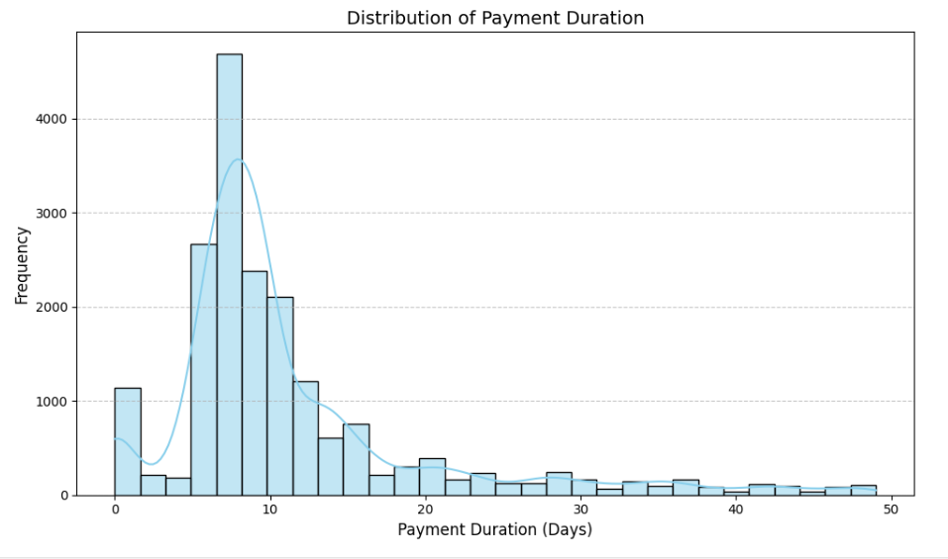
Figure 4.1.1 Distribution of payment duration.

It is noticeable in the histogram that the majority of payments happen fast and only a few take more time. Most transactions fall between 5 and 10 days, with a big peak showing that day 8 is when payment is most often made. Payments posted further beyond the first 10 days decline slowly, ending up in a long line that stretches to outlier situations where transactions took over 50 days. Although payment is made quickly in most cases, a small number of claims are delayed which leads to the skewness shown in the data.

Further categorical breakdowns provided additional insights. For example:

Table 4.1.2 Average Payment Duration by PMB Status
PMB Status | Mean Payment Duration (days) | Median Payment Duration (days) | Number of Claims
PMB | 11.73 | 9 | 13412
NON-PMB | 10.61 | 8 | 5555

Table 4.2.1 reports the average length of time claims with and without Prescribed Minimum Benefits (PMB) require payment. It is evident that PMB claims took slightly longer to be paid (11.73 days) when compared with non-PMB claims (10.61 days).

Table 4.1.3: Average Payment Duration by Contract Status
Contract Status | Mean Payment Duration (days) | Median Payment Duration (days) | Number of Claims
CONTRACTED | 10.82 | 9 | 16438
NON-CONTRACTED | 15.22 | 10 | 2529

Table 4.1.3 suggests that payments to non-contracted providers (mean = 15.22 days) took longer than those to contracted providers (mean = 10.82 days) which is likely because there are more steps needed compared to those for contracted providers.

4.2 Modelling Process

4.2.1 Model Performance
Model performance was evaluated using Mean Square Error (MSE), Mean Absolute Error (MAE), and R-squared (R²). The results for all models on the validation set are summarized in Table 4.2.1

Table 4.2.1: Model Performance Comparison
Model | MSE | RMSE | MAE | R-squared
Linear Regression | 77.32 | 8.79 | 5.74 | 0.0448
Decision Tree | 93.64 | 9.67 | 5.78 | -0.1567
Gradient Boosting | 67.43 | 8.21 | 5.48 | 0.1670
Lasso Regression | 80.10 | 8.95 | 6.08 | 0.0105
Random Forest | 65.66 | 8.10 | 4.96 | 0.1889

The Random Forest Regressor performed best of all models, having the smallest MSE (65.66) and RMSE (8.10) which means its predictions were more accurate. It achieved a smaller reporting error (4.96) for predicted payment completion duration than the other models. Furthermore, it achieved the greatest R² score (0.1889), meaning that it was the best at explaining differences in payment durations—better than the other models.

The Gradient Boosting Regressor came next, having a low MSE (67.43), a lower MAE (5.48) than some models and an R² of 0.1670, so it was better at predicting outcomes but explained slightly less variability than the Random Forest model.

Both Linear Regression and Lasso Regression achieved poorer results than Random Forest. Lasso recorded the highest MAE (6.08), so its average predictions were the least accurate of all models tested.

Decision Tree Regressor was not effective, resulting in the highest MSE of all, with 93.64, the highest RMSE at 9.67 and showing a negative R² score of -0.1567. If R² is negative, it means the model’s performance was worse than the mean prediction and there was overfitting.

4.2.2 Feature Importance
The Top 10 Feature Importance listed on the bar chart come from the Random Forest model which generated the most accurate results for payment duration.

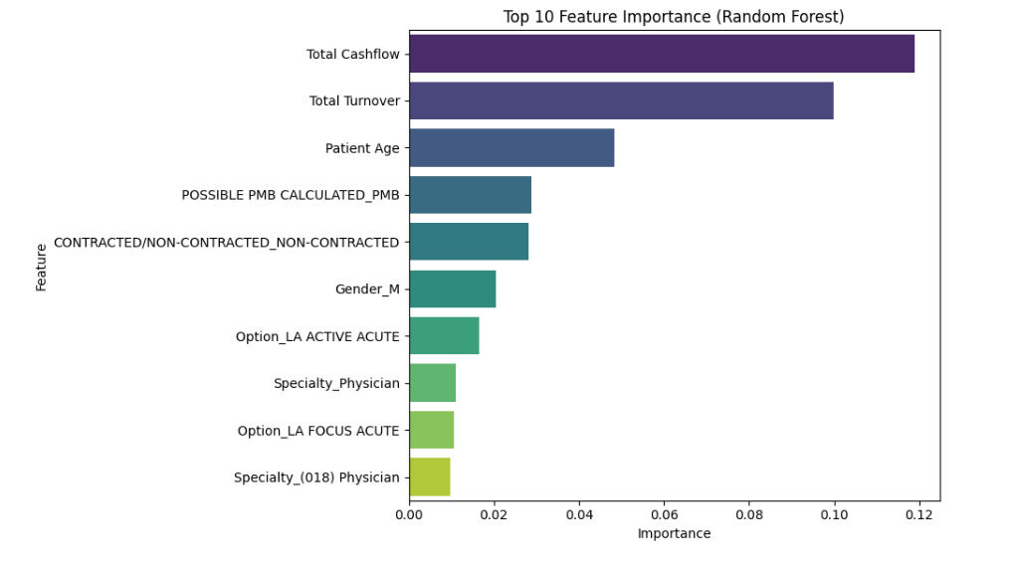
Figure 4.2: Top 10 features influencing payment duration

According to the Random Forest model, financial factors play the largest role in predicting payment duration. It was apparent from the results that Total Cashflow and Total Turnover were the most important factors since payments influenced processing time the most. The age of the patient, their contract status and if the benefit is classed as a Prescribed Minimum Benefit (PMB) all matter. Demographics and the details of medical plans play a moderate role, suggesting that both money and paperwork affect the speed of claim settlement.

4.3. Payment Duration Analysis Dashboard

This dashboard offers a high-level summary of how well Random Forest model predicts payment durations compared to actual values from the original dataset. It highlights key metrics, age-related comparisons, and distribution patterns for better operational understanding.

Overview
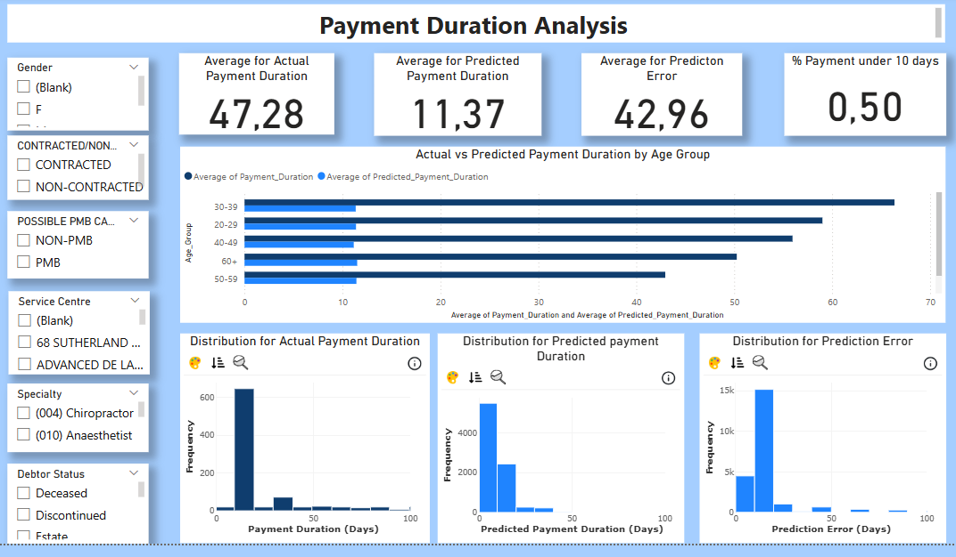

This section explains the expected and actual durations of medical insurance payments. The data at the top shows that the average actual payment duration is 47.28 days, much longer than the predicted average of 11.37 days from the model which results in a big prediction gap of 42.96 days. Significantly, over half of all payments are finished within 10 days.

The bar chart shows that, for every age group, the actual payment times from uncleaned data always last much longer than the predicted times. Histograms in the bottom section show how the actual payment durations, estimated payment durations and errors are distributed. The visuals indicate that outliers affect the original data, so the distribution of actual durations is very spread out, but the predicted durations remain clustered together.

There are interactive filters found in the left menu for users to organize data using gender, provider contract status, PMB claims, service center, medical specialty and debtor status. This dashboard displays payment trends, measures how well the model works on reformed data and helps point out places where payment processing could be enhanced. Such a big difference between the predicted and actual numbers highlights why the data in predictive modeling must be of high quality.

Service Centre Performance
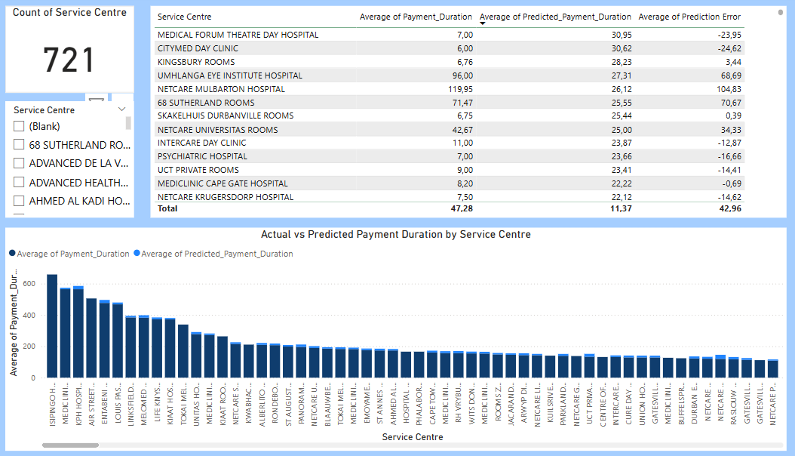

This page displays how various service centres fared in payment delays and compares their results with the model’s predictions. Service centres vary a lot in their performance, with a total of 721 in operation.

Some centres, for example Netcare Mulbarton Hospital and 68 Sutherland Rooms, had extended actual payment times (over 70 and even 119 days), but these were far longer than the model predicted (approximately 25 days). It means that the model isn’t effective at catching serious delays, as it was built using cases that were clearer and less complex.

As for Citymed Day Clinic, the actual treatment process didn’t take long, about 6 days, however, the model predicted a delay of more than 30 days. So, the model also struggles when dealing with sudden claims by giving longer times than it actually should.

We can confirm this trend by looking at the bar chart at the bottom. In most cases, locations with more delay have larger differences between actual and predicted waiting times, whereas low-delay locations don’t. The model provides good results for average waiting times yet fails for the most and least delayed hospitals.

Specialty Breakdown
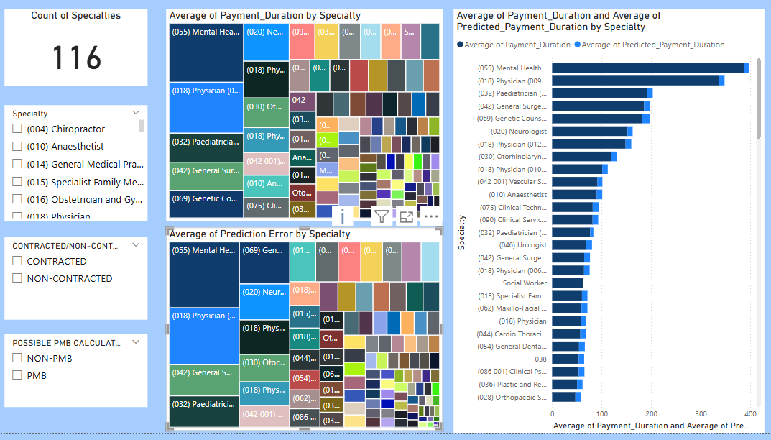

This page shows how payment durations vary across 116 medical specialties and how well the model predicted those durations.

The bar chart on the right compares actual and predicted payment durations. Specialties like Mental Health, Physicians, and Paediatrics have the longest actual payment delays, but the model consistently predicted much shorter times. This led to high prediction errors, especially in complex or specialized care areas.

The tree maps on the left visually highlight these differences. The top map shows which specialties had the highest payment durations, while the bottom shows where prediction errors were largest. The biggest gaps appear in specialties that may involve extra paperwork or approval steps not captured in the model.

On the other hand, the model performed better in more routine areas, like Urology, Social Work, and General Practice, where actual and predicted durations were closer.

Prediction Accuracy
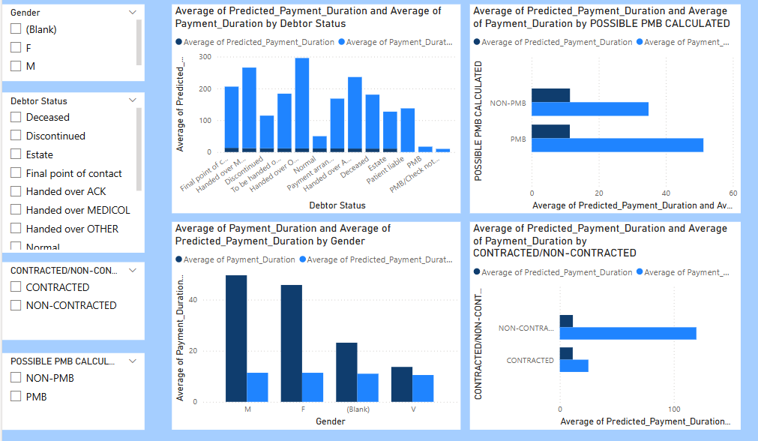

This page breaks down payment duration and prediction accuracy by four key variables: debtor status, PMB status, gender, and contract status. It compares actual payment durations to predicted values for each group.

Debtor Status
The bar chart shows that accounts marked as “Handed over” or in poor standing (e.g., “Handed over MEDICOL” or “Final point of contact”) had significantly longer payment durations, often over 200 to 300 days compared to model predictions, which remained under 50 days. This indicates the model did not capture the impact of problematic debtor statuses, resulting in major underestimates.

PMB (Prescribed Minimum Benefit) Status
Claims linked to PMBs took longer on average than non-PMB claims. The model also underpredicted both groups, but especially PMB claims, where the actual duration was nearly 60 days, while predicted duration was much lower. This suggests that PMB-related claims face additional processing steps not captured in the model.

Gender
Male and female patients both had longer actual payment durations (especially males), while the model predicted much shorter durations for both. This may reflect differences in claim types or care complexity by gender that were not factored into the model.

Contracted vs Non-Contracted Providers
Non-contracted providers had far longer payment durations than contracted providers, which aligns with earlier findings. Again, the model underestimated both, but the gap was much wider for non-contracted claims. This confirms that contract status is a strong driver of delay, and that prediction accuracy varies significantly by this factor.

Financial Relationship
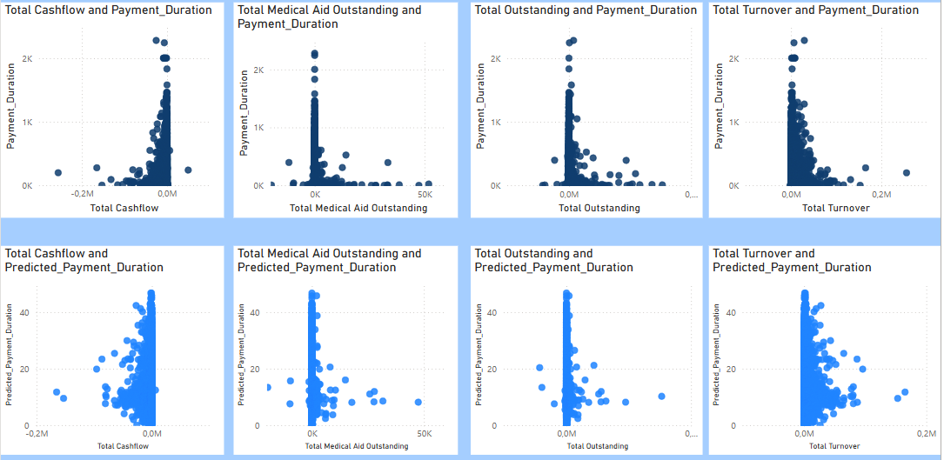

This page examines how four financial variables: Total Cashflow, Total Medical Aid Outstanding, Total Outstanding, and Total Turnover relate to both actual and predicted payment durations.

In the top row of scatter plots, which shows actual payment durations, most claims with lower financial values are paid quickly. However, as the financial amounts increase, payment durations become more spread out, with some cases experiencing extreme delays exceeding 2,000 days. This pattern is especially clear with Total Cashflow and Total Turnover, where high values are occasionally linked to very long delays.

In the bottom row, the predicted durations are much more concentrated, mostly staying below 50 days regardless of the financial amount. This indicates that the model identifies a general trend of longer durations for higher-value claims but fails to capture the full range of delays seen in the actual data.

Overall, the dashboard shows that financial metrics do impact payment delays, but the model underestimates this impact, especially for high-value or complex claims. To improve predictions, future models may need additional inputs such as claim complexity, approval steps, or process status indicators.

Interpretation and Recommendations

This section interprets the modelling results against business objectives, provides practical recommendations, discusses limitations, and suggests future research, while connecting findings to existing literature.

Interpretation of Results Relative to Business Success Criteria

The findings of the analysis closely match the set business success criteria which included discovering the factors behind late payments, developing a forecast model and providing advice to enhance efficiency in private medical insurance. According to the analysis, claims were usually paid 11.4 days after being filed, but there was a strong right skew in the data, showing that most payments took a shorter time than the average and a few were delayed for a long time. The Random Forest Regressor was the strongest predictive model because it had the smallest mean squared error (65.66) and highest R-squared value (0.1889), meaning it explained almost 19% of the changes in payment durations. Even with a moderate accuracy, the data gives valuable advice on what to do. Total Cashflow and Total Turnover played the key role in predicting changes, followed by Contract Status and the classification of PMB. The analysis showed that contracted providers resulted in a shorter payment time (mean of 10.82 days) than non-contracted providers (mean of 15.22 days) and the lengthier delay for PMB cases was probably due to dealing with specific regulations.

Additional insights are presented in the dashboard found in Section 4.3, allowing users to understand gaps in payment duration for patients based on age, service centers, medical specialties and financial indicators. Graphs allow users to see where the model excelled or fell short, further confirming the analysis according to expected business success criteria.

Practical Recommendations and Business Implications

There are many things that can be done to make payments more efficient and in line with the company’s aims. To begin with, the organization should increase the number of contracted providers since this means claims are processed faster and cash flow is improved. Plus, introducing dashboards that instantly pick out potentially high-risk or large transactions can speed up the process of giving priority.

Creation of automated or dedicated solutions for reviewing PMB-related claims is needed to deal with delays. Because Random Forest proved to have the highest prediction accuracy, it should be used in operations to flag claims that may experience delays.

Last, data collection can be improved further by including extra elements like the amount of work employees are handled, the state of documents and the timing of system logs. They can increase the accuracy of the model and show us new findings. Applying these recommendations can cut costs for administration, foster good provider relationships and enhance member satisfaction, which are important preparations for NHI.

Limitations and Future Research Directions

The research gave useful information about what affects how long private medical insurance payments take, but it was limited by some factors. Predicting future payment durations using the best-performing model was not very accurate, since it could only explain around 19% of the differences seen in payments. Therefore, we can’t be sure that variables such as document quality, errors made by humans or delays in the administrative process were documented in the dataset. It was also necessary to limit the dataset to strictly paid invoices, meaning only those that were paid in full were included. For this reason, risks associated with delayed payments, refusals and disputes could not be analyzed thoroughly.

Furthermore, when data is anonymized and imputation is applied, it may introduce error or conceal important trends among groups of patients or areas of service. Static data from previous years was used in the analysis, even though things such as season, laws and the implementation of the NHI might have changed.

Future work should attempt to overcome these restrictions by studying actual times or long periods to check how external changes, including the various phases of rolling out the NHI, impact payment durations. In addition, bringing qualitative input from claim processors and healthcare providers may reveal procedural obstacles that standard data does not show. It is possible that using XGBoost or neural networks, along with more expanded data, will result in better predictions and give us additional insight than simple regression methods.

5.4 Relation to Existing Literature and Studies
The outcomes of this study agree with what is known from other studies on processing healthcare claims. The authors point out that administrative inefficiencies and digital transformation reflect the views of Smith and Mokoena (2021). Payment timelines for providers with different contract status agree with Lee et al. (2022).

Seeing 'Total Cashflow' and 'Total Turnover' in the model allows observing the effect of financial magnitudes on processing challenges. The PMB claims relate to policy and regulatory matters described by the Competition Commission’s Health Market Inquiry in 2019.

The findings of this research support discussions on Universal Health Coverage (NHI) in South Africa (Molefe, Dlamini and Jacobs, 2023). The results presented in this study can be used to build more efficient systems for managing claims and payments under the NHI, as these lessons can address issues of fluctuating payments and contracts.

Conclusion

The study of LA Health claims found that most claims were paid out in a short amount of time, yet this time varies greatly depending on the exact claims information. It took slightly longer to deal with claims from Prescribed Minimum Benefits and claims from non-contracted providers took much longer. The model that performed best, a Random Forest Regressor, described 18.89% of the changes in payment timings and the factors linked to finances and administration turned out to be the biggest influencers. These results imply that automated assessment of important claims and broader contracting with health providers might improve the way claims are handled.

The research is relevant to currently ongoing policy talks in the South African healthcare sector. It builds on the Competition Commission’s findings by supporting suggestions for standardised payment and it agrees with comments from researchers and policy analysts on needing data for fair claims management. While the country rolls out the NHI, this research gives helpful tips to private insurers on how to improve their handling of claims.

References

- Chothia, F. (2024) ‘Why South Africa’s health insurance is causing ructions’, BBC News, 15 May. Available at: https://www.bbc.com/news/articles/c1030v3p1r8o
- Competition Commission of South Africa (2019) Health Market Inquiry: Final Findings and Recommendations. Pretoria: Competition Commission of South Africa. Available at: https://www.compcom.co.za/wp-content/uploads/2020/01/Final-Findings-and-recommendations-report-Health-Market-Inquiry.pdf
- Heywood, A. (2022) ‘Patient perspectives on medical scheme delays and trust in South Africa’, South African Medical Journal, 112(6), pp. 300–305.
- Lee, J., Muller, P. and van der Merwe, L. (2022) ‘Predicting insurance claim payment times via machine learning’, International Journal of Medical Informatics, 156, 104614.
- Molefe, T., Dlamini, V. and Jacobs, L. (2023) ‘Payment inefficiencies and the National Health Insurance transition in South Africa’, South African Health Policy Journal, 2(1), pp. 30–39.
- Smith, J. and Mokoena, S. (2021) ‘Administrative inefficiencies and payment delays in South African medical schemes’, South African Journal of Healthcare Management, 17(4), pp. 45–53.
- The Presidency. (2024) ‘From the desk of the President - Monday, 20 May 2024’, The Presidency, 20 May. Available at: https://www.thepresidency.gov.za/node/8149

